CERT-In Compliance for Log360 Cloud
Strengthen cybersecurity and meet CERT-In compliance with Log360.
Region: India | Type: General Compliance | Category: Compliance | Pricing: Free

Overview
The CERT-In compliance extension in Log360 helps organizations meet CERT-In Directions under Section 70B(6) of the IT Act (India, April 2022), India's mandatory cybersecurity directive requiring service providers to report incidents within 6 hours, retain ICT logs for 180 days, and synchronize clocks to NTP by providing centralized log management, incident alerting, log archival, and real-time security monitoring. The platform supports CERT-In requirements for incident detection, 6-hour reporting, 180-day log retention, NTP synchronization, access auditing, network monitoring, and vulnerability assessment.
For Mandatory Cyber Incident Detection and Reporting, Log360 provides real-time alerting to support the strict 6-hour mandatory reporting window. To address ICT Log Maintenance and 180-Day Retention, the platform centralizes and archives these logs from all sources to meet the 180-day retention mandate. The extension also supports System Time Synchronization Monitoring by providing capabilities that validates log timestamp consistency across sources to detect clock drift and synchronization failures.

Key Features
- Access Control and Authentication Auditing: Log360 consolidates authentication events from Windows, Unix, Active Directory, and cloud identity providers.
- Network Infrastructure and Traffic Monitoring: Log360 aggregates network device logs from firewalls, routers, and switches to support incident investigation.
- Mandatory Cyber Incident Detection and Reporting: Log360 provides real-time alerting to support the strict 6-hour mandatory reporting window.
- ICT Log Maintenance and 180-Day Retention: Log360 centralizes and archives these logs from all sources to meet the 180-day retention mandate.

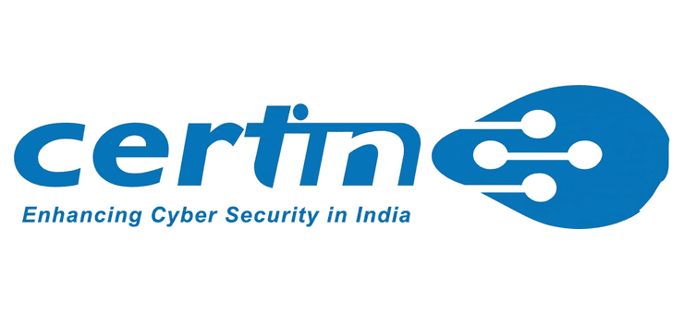
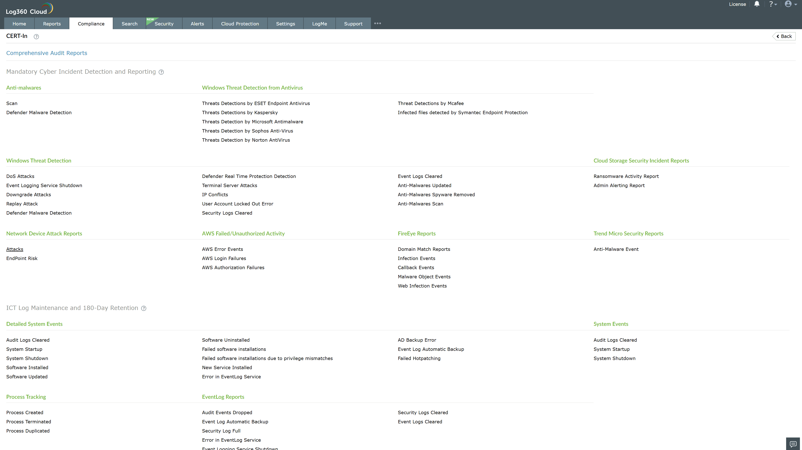
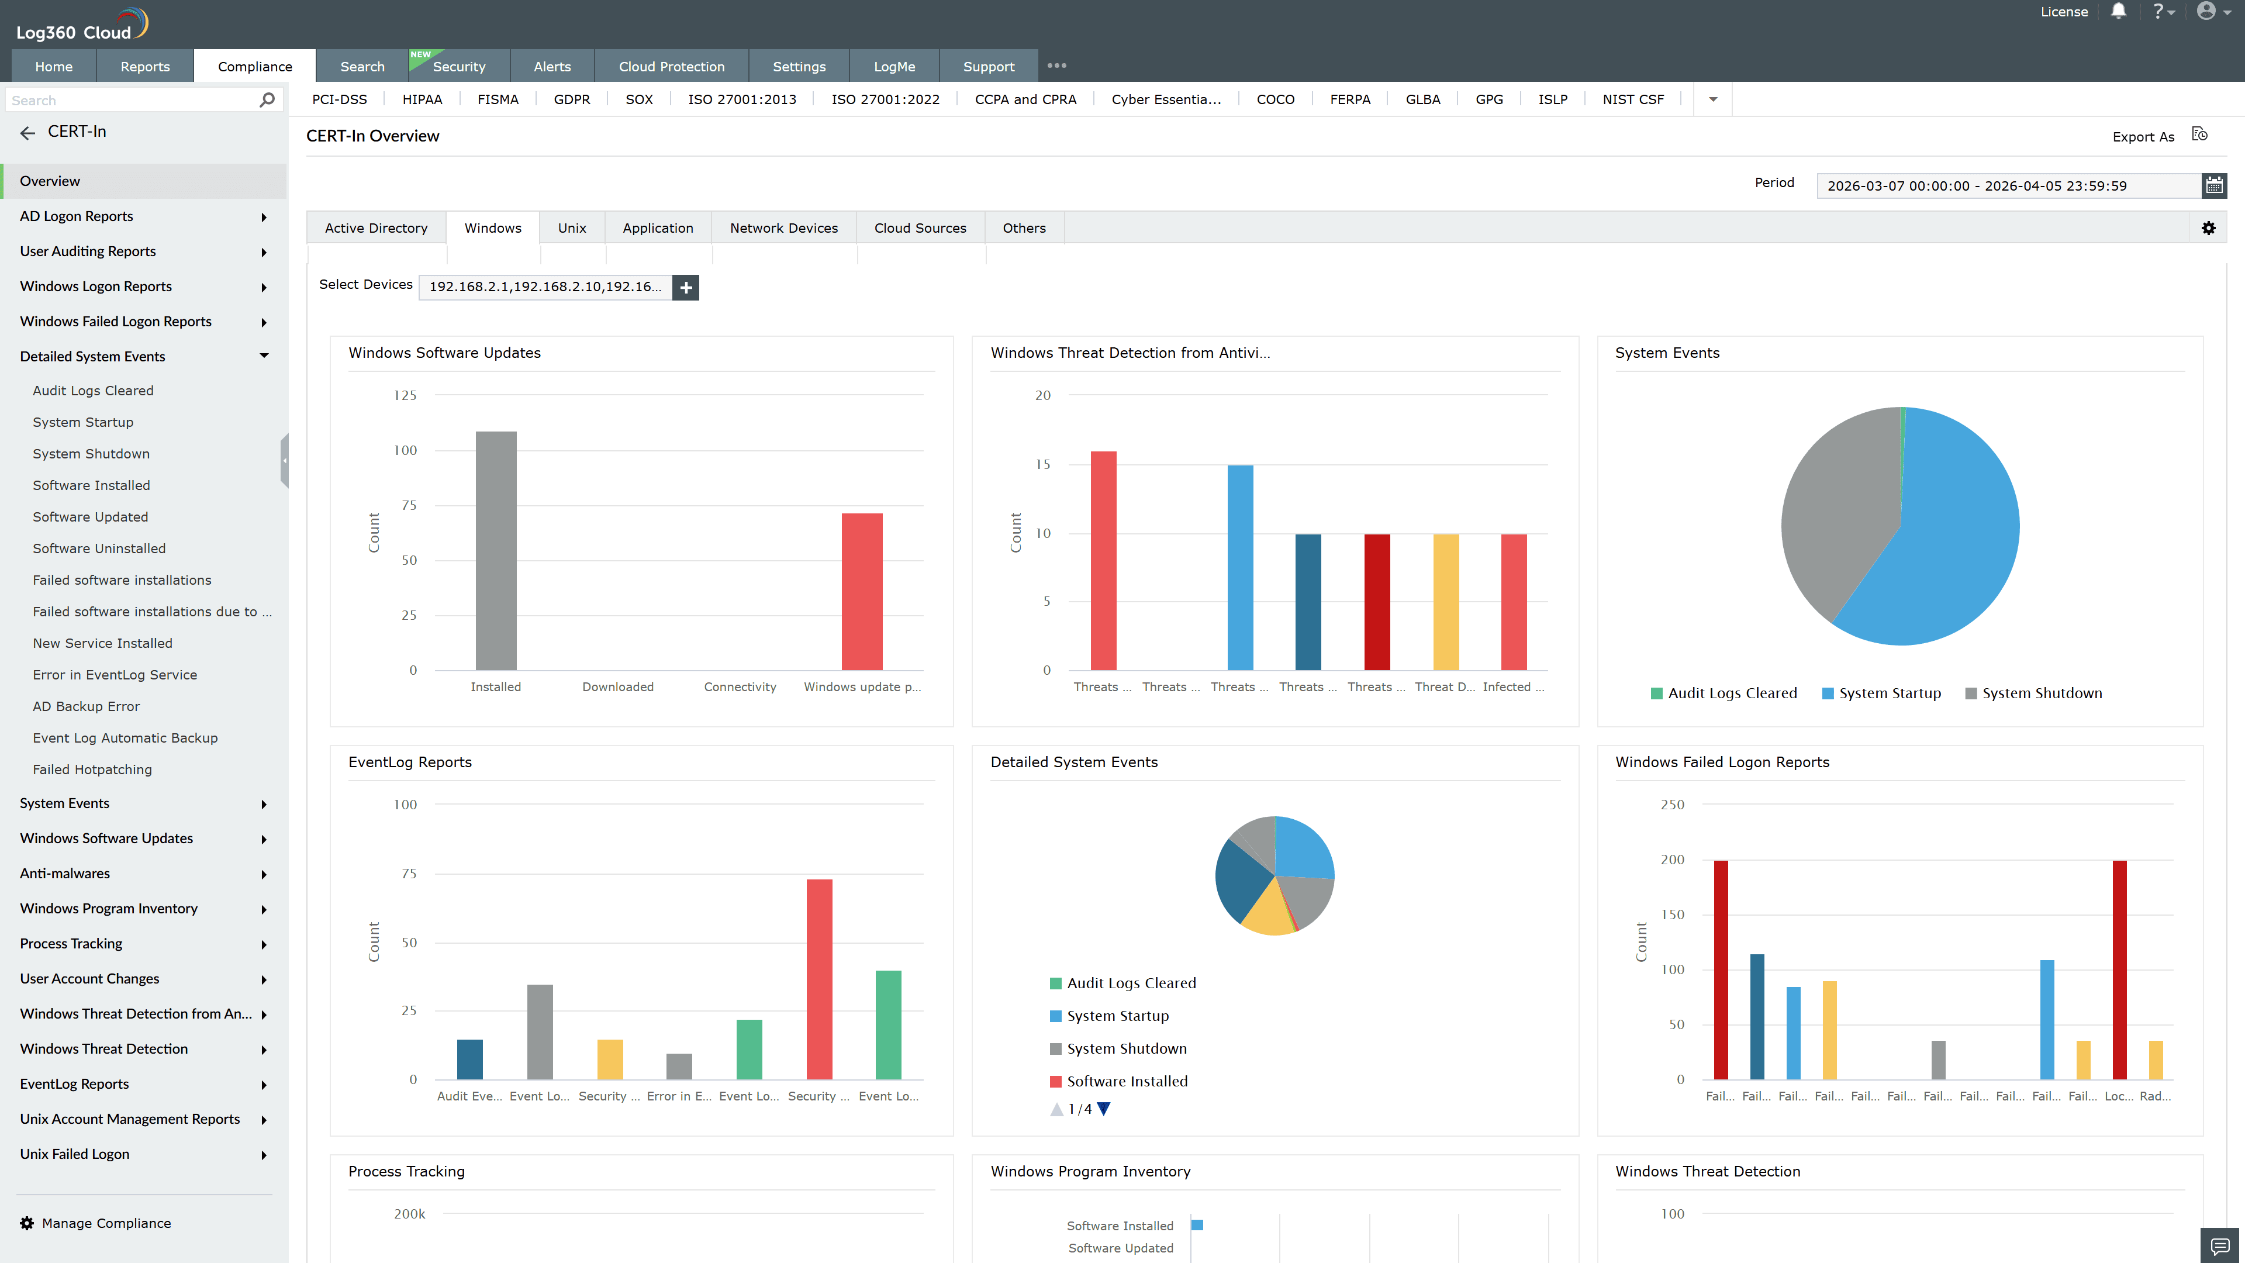
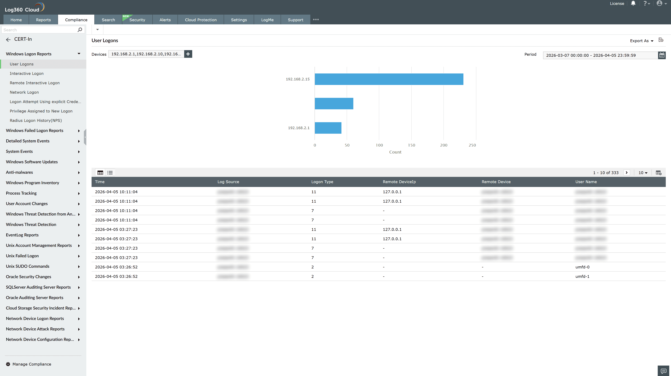
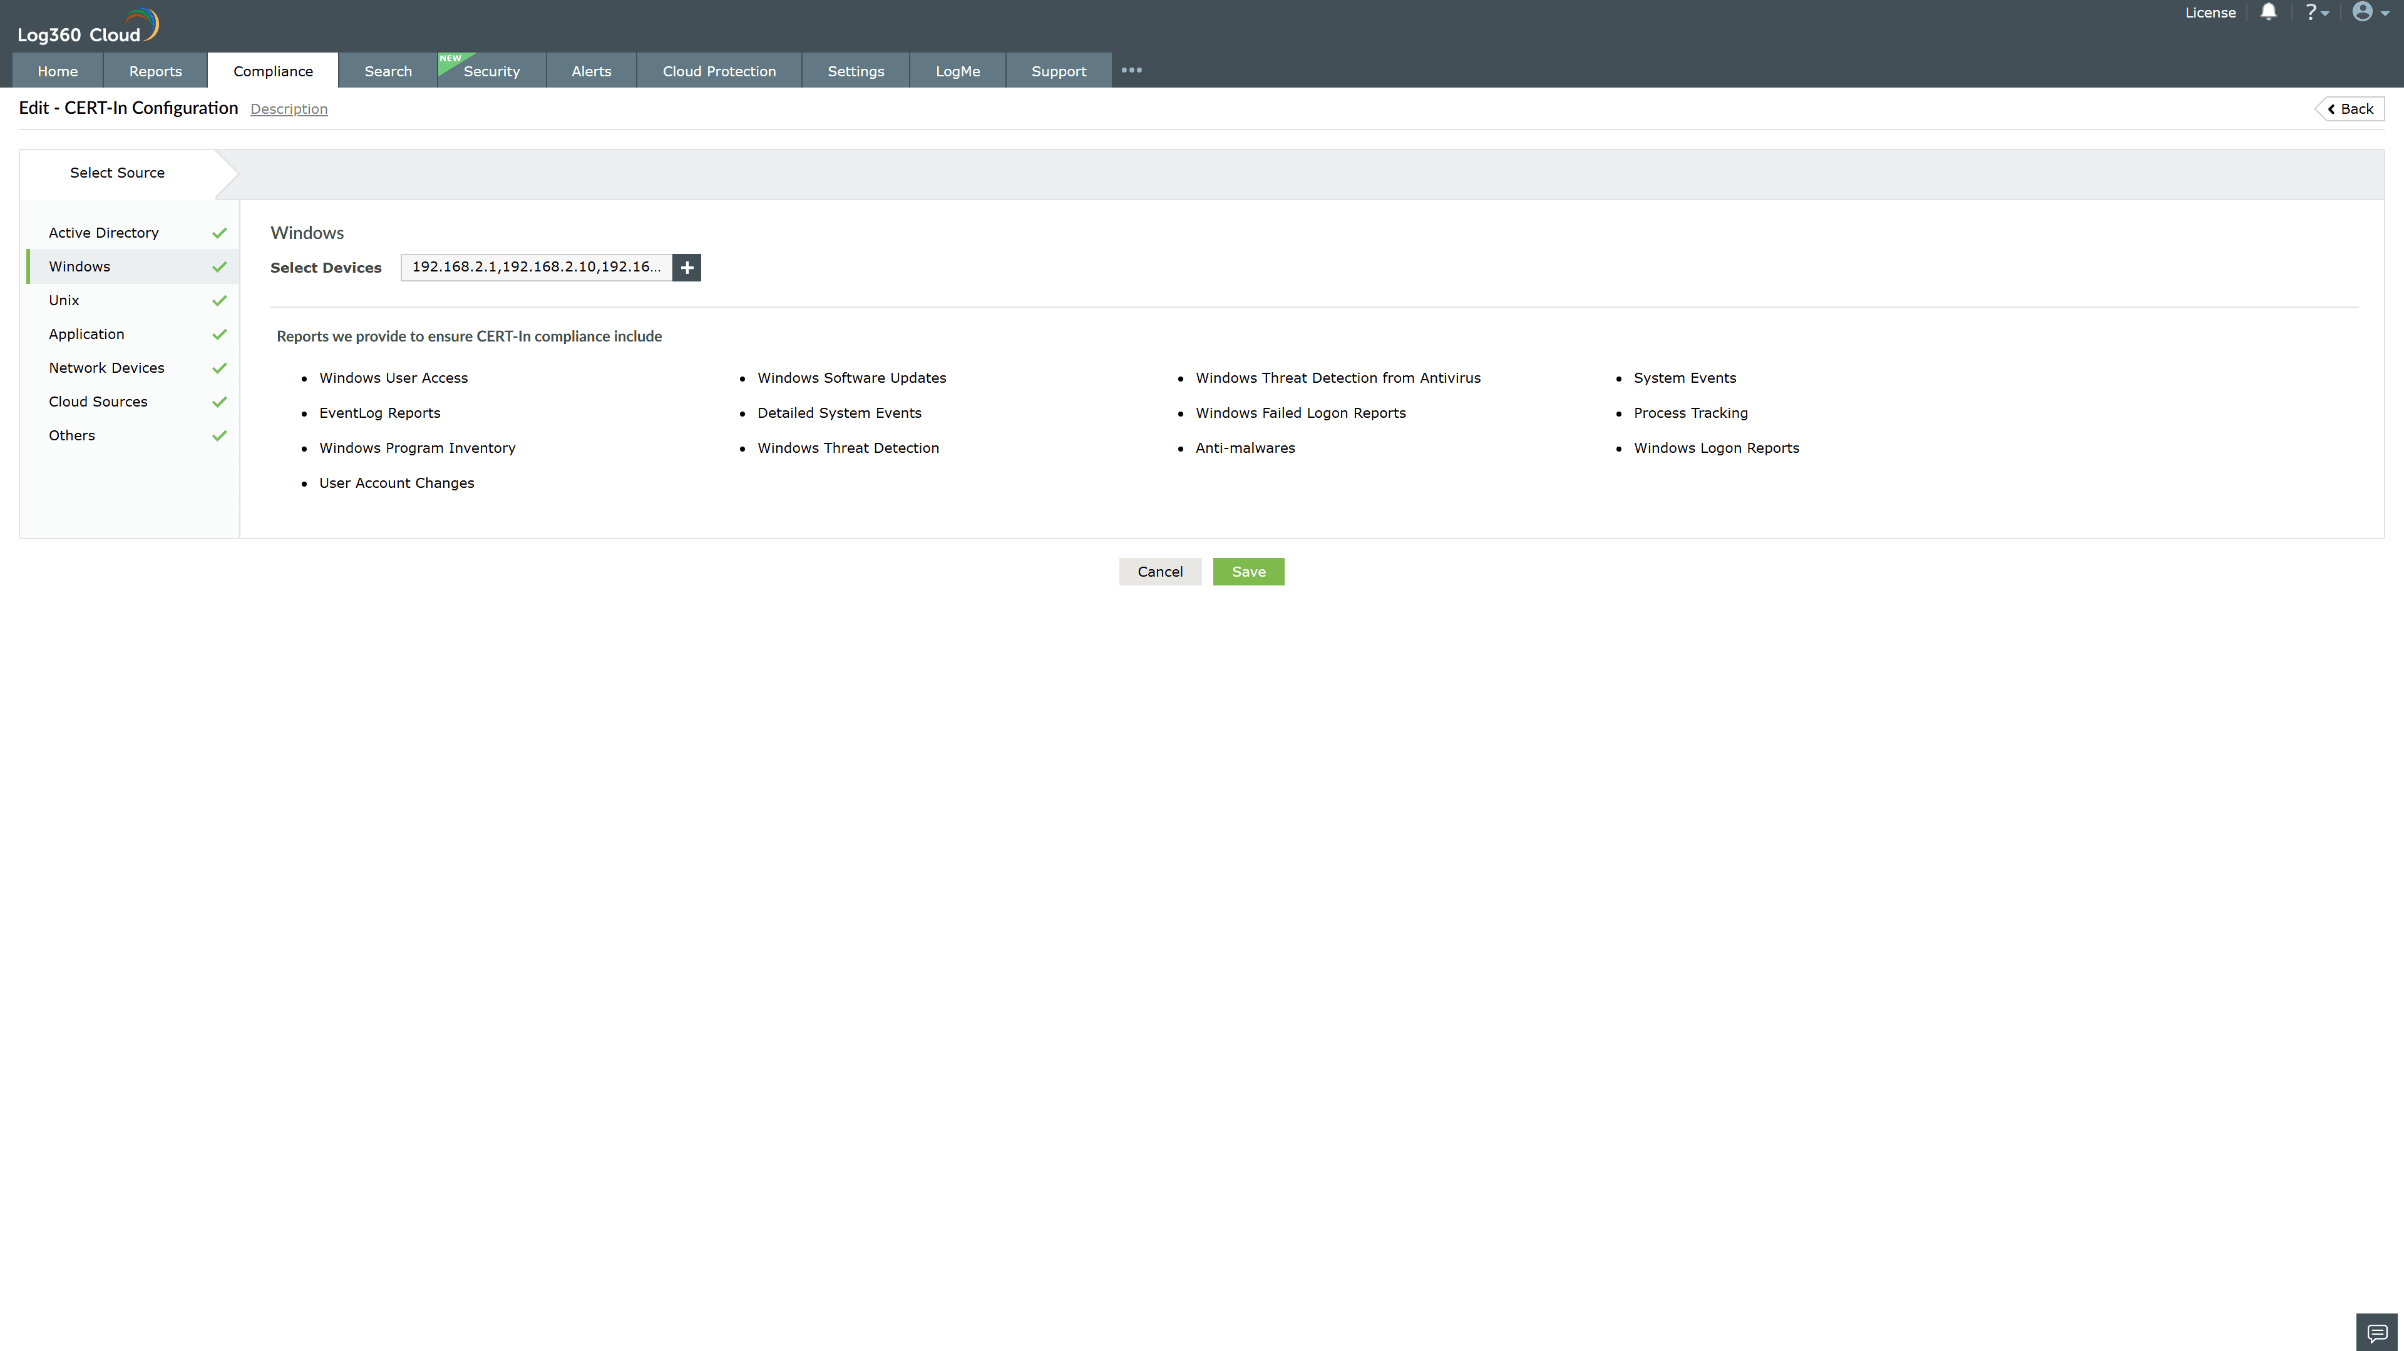
Valid Submission : Yes
Supported Editions : Free, Basic, Standard, Professional, MSSP
Help Document : https://www.manageengine.com/log-management/help/integrations/compliance-extensions.html
Help Video : Not provided
Tags : Log360, Compliance, Privacy monitoring, Data privacy, Regulatory compliance
Supported DCs : US, IN, JP, CA, AU, UK and EU
Privacy Policy:
Terms of Service:
Release Notes:
Predefined reports for the CERT-In.

